1. Download Keil MDK-ARM software (v5.31 as of 1 Sept 2020) at <https://www.keil.com/demo/eval/arm.htm#/DOWNLOAD>

2. Run .exe file that downloads and go through default setup

3. “Pack Installer” opens automatically after download

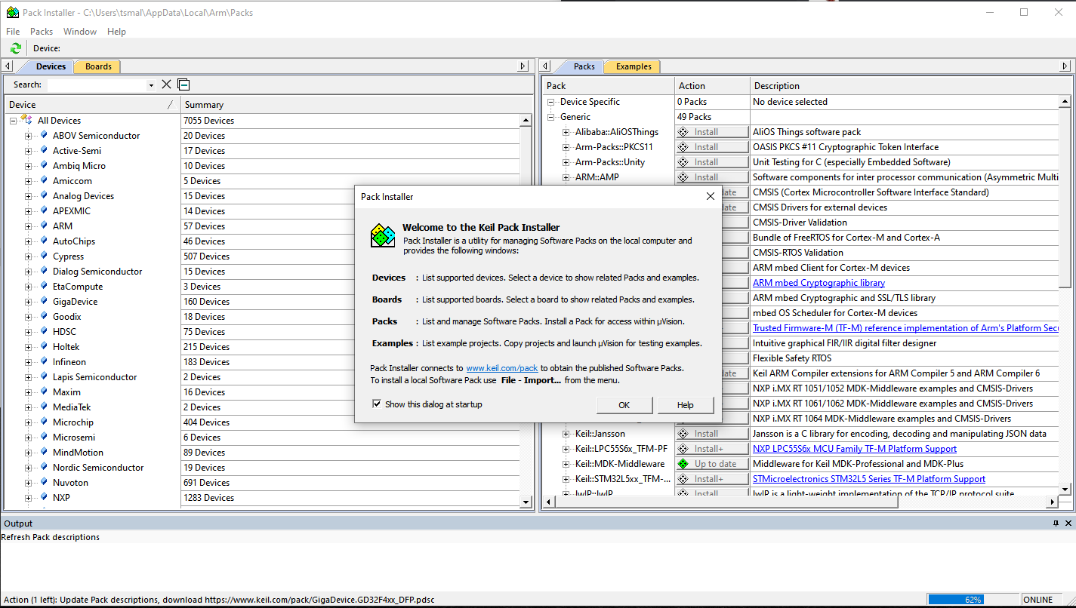

4. Select board by: Board tab > FRDM-K22F > MK22FN512xxx12 > MK22FN512VLH12

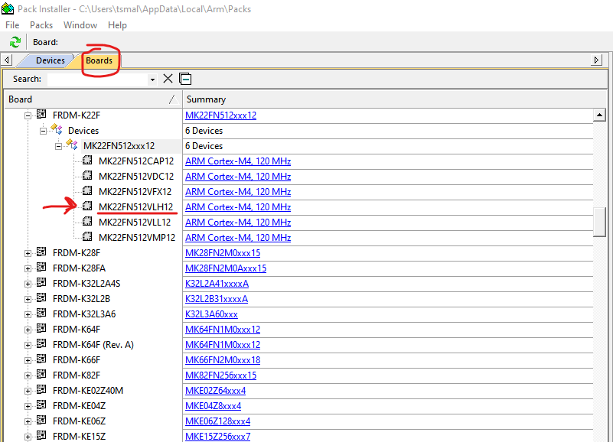

5. The “Device Specific” packs should appear in “Packs” tab. Install all of them

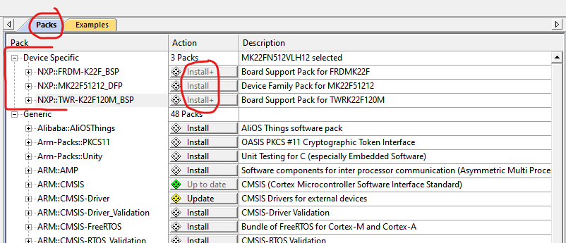

6. Under the “Action” column, update any packs you already have installed that have updates

7. Go to “Examples” column. Scroll down to hello world example and click “Copy”

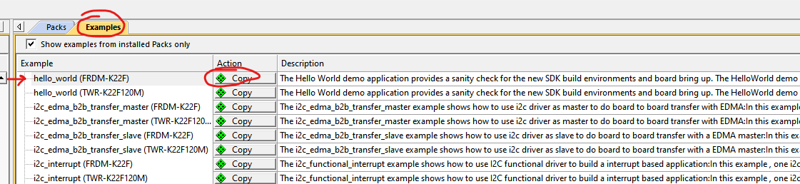

8. This should open in Keil uVision5 IDE

9. Project > Options for Target … > Utilities > under “Use Target Driver for Flash Programming” click on “Settings” > Flash Download > Add > Add “MKxxN 512kB Prog Flash”

10. Project > Build Target. This should only take a second to build

11. At this point… install PuTTY if not already installed

<https://www.chiark.greenend.org.uk/~sgtatham/putty/latest.html>

12. Connect Freescale dev board to PC through USB. Use the USB connector closer to the corner of the board (this one is for power/debug)

13. Go to windows start menu > device manager > Ports > see which port the “mbed” device is using

14. Open PuTTY session

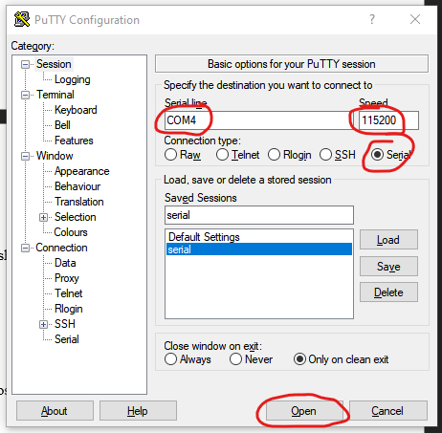

15. In Keil IDE: Flash > Download (this should take a few seconds and you’ll see a progress bar at the bottom)

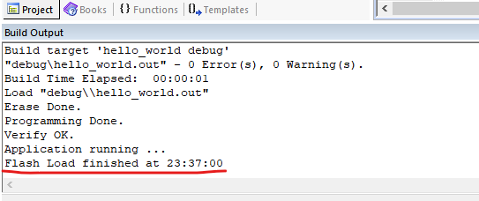

16. magic

